Title: Reconstruction of OD curve for Microcystis aeruginosa in Zoo-COMBO medium
Date: Friday 27th March 2026
Aim: Having the optical density of different densities of Microcystis aeruginosa in Zoo-COMBO medium. We will then send out the samples to know how much carbon was exactly at each density. Algae throughout the protocol refers to Microcystis aeruginosa.
Material:
Prepared | Amount | Material | Purpose
☐ | 1 | Vacuum filtration pump | To pull phytoplankton through the GF/C filter
☐ |  | Pre-combusted (2h in 550°C) GF/C filters (25mm) | To capture the phytoplankton
☐ | 2 | Forceps | To manipulate the filters
☐ | 1 | 24-well plate | To store the filters to then be dried
☐ | 1 | 96-well plate | To store the filters to then be analysed
☐ | 1 | Pipette and tips | To pipette phytoplankton on filters
☐ | 1 | Metal block | To wrap the aluminium foil around the filters
☐ |  | Aluminium cartridges | To wrap the filters so that they can be already analysed

Steps:
Part I – Take out Algae & replace COMBO with Zoo-COMBO
- Create Algae pellets.
  - Add 48 ml of algae to each centrifuge tube (use the auto pipette and the pipette tip with the written the name of the algae).
  - Transform the inoculated algae into a pellet by spinning the Falcon tubes for 10 minutes at 28,000 revolutions per minute.
  - Meanwhile you are waiting for the centrifuge to be done, turn on the spectrophotometer.
  - Throw out the liquid (phytoplankton COMBO) from the falcon tubes. Do this as quickly as possible after the spinning to avoid resuspension.
  - Add 48 ml of Zoo-COMBO to each of the falcon tubes. Then mix them into a Becker.
Part II – Perform dilutions
Create different bottles of 50 ml each, with Zoo-COMBO, algae in Zoo-COMBO, and algae diluted in Zoo-COMBO at 10, 25, 35, 50, and 75% of the original density.
What | Algae (ml) | Zoo-COMBO (ml)
Zoo-COMBO | 0 | 50
10% of original density | 5 (50 ml * 0.1) | 45 (50 ml – 5 ml)
25% of original density | 12.5 (50 ml * 0.25) | 37.5 (50 ml – 12.5 ml)
35% of original density | 17.5 (50 ml * 0.35) | 32.5 (50 ml – 17.5 ml)
50% of original density | 25 (50 ml * 0.5) | 25 (50 ml – 25 ml)
75% of original density | 37.5 (50 ml * 0.75) | 12.5 (50 ml – 37.5 ml)
Original density | 50 | 0

Part III – Record optical density
Record the optical density of the algae in Zoo-COMBO at different densities.
What | Absorbance (480 λ)
Zoo-COMBO
10% of original density
25% of original density
35% of original density
50% of original density
75% of original density
Original density

Part IV – Set up the vacuum filtration pump and filtration system
- Set up material.
  - Set up the vacuum filtration pump and connect its tube to the wall gas supply (the tube sucks air in, allowing the liquids to come more easily through the filter).
  - Add GF/C filters (they should have been burnt at 550 °C for 2 hours) on the filtration unit using clean forceps (cleaned with ethanol and fire – hold forceps horizontally while burning).
  - Add cylinder weights on top of the filters.
  - Turn on suction slowly, checking on the filtration unit that the pressure doesn’t exceed 0.2 bar.
- Add samples to the filters. For each of the samples:
  - Pipette culture on the filter (remember to mix well the sample, and make sure that the liquid goes through, otherwise adjust the tap until no liquid is left on top of the filter). Write down how much volume you added to the filter in the below table.
  - Move the filters to a 24-well plate. To do so, turn off the suction, take off the cylinder weights, and move filters to the 24-well plate with clean forceps (cleaned with ethanol and fire). Place each sample in the plate position noted in the below table.
  - Clean. Put back cylinder weights and turn on suction. Then, clean meshes and cylinders by pouring ethanol and demineralised water on them.
- Repeat previous point with the remaining filters.

What | Volume added (ml) | Plate position
Zoo-COMBO |  | A1
Zoo-COMBO |  | A2
10% of original density |  | A3
10% of original density |  | A4
25% of original density |  | A5
25% of original density |  | A6
35% of original density |  | B1
35% of original density |  | B2
50% of original density |  | B3
50% of original density |  | B4
75% of original density |  | B5
75% of original density |  | B6
Original density |  | C1
Original density |  | C2

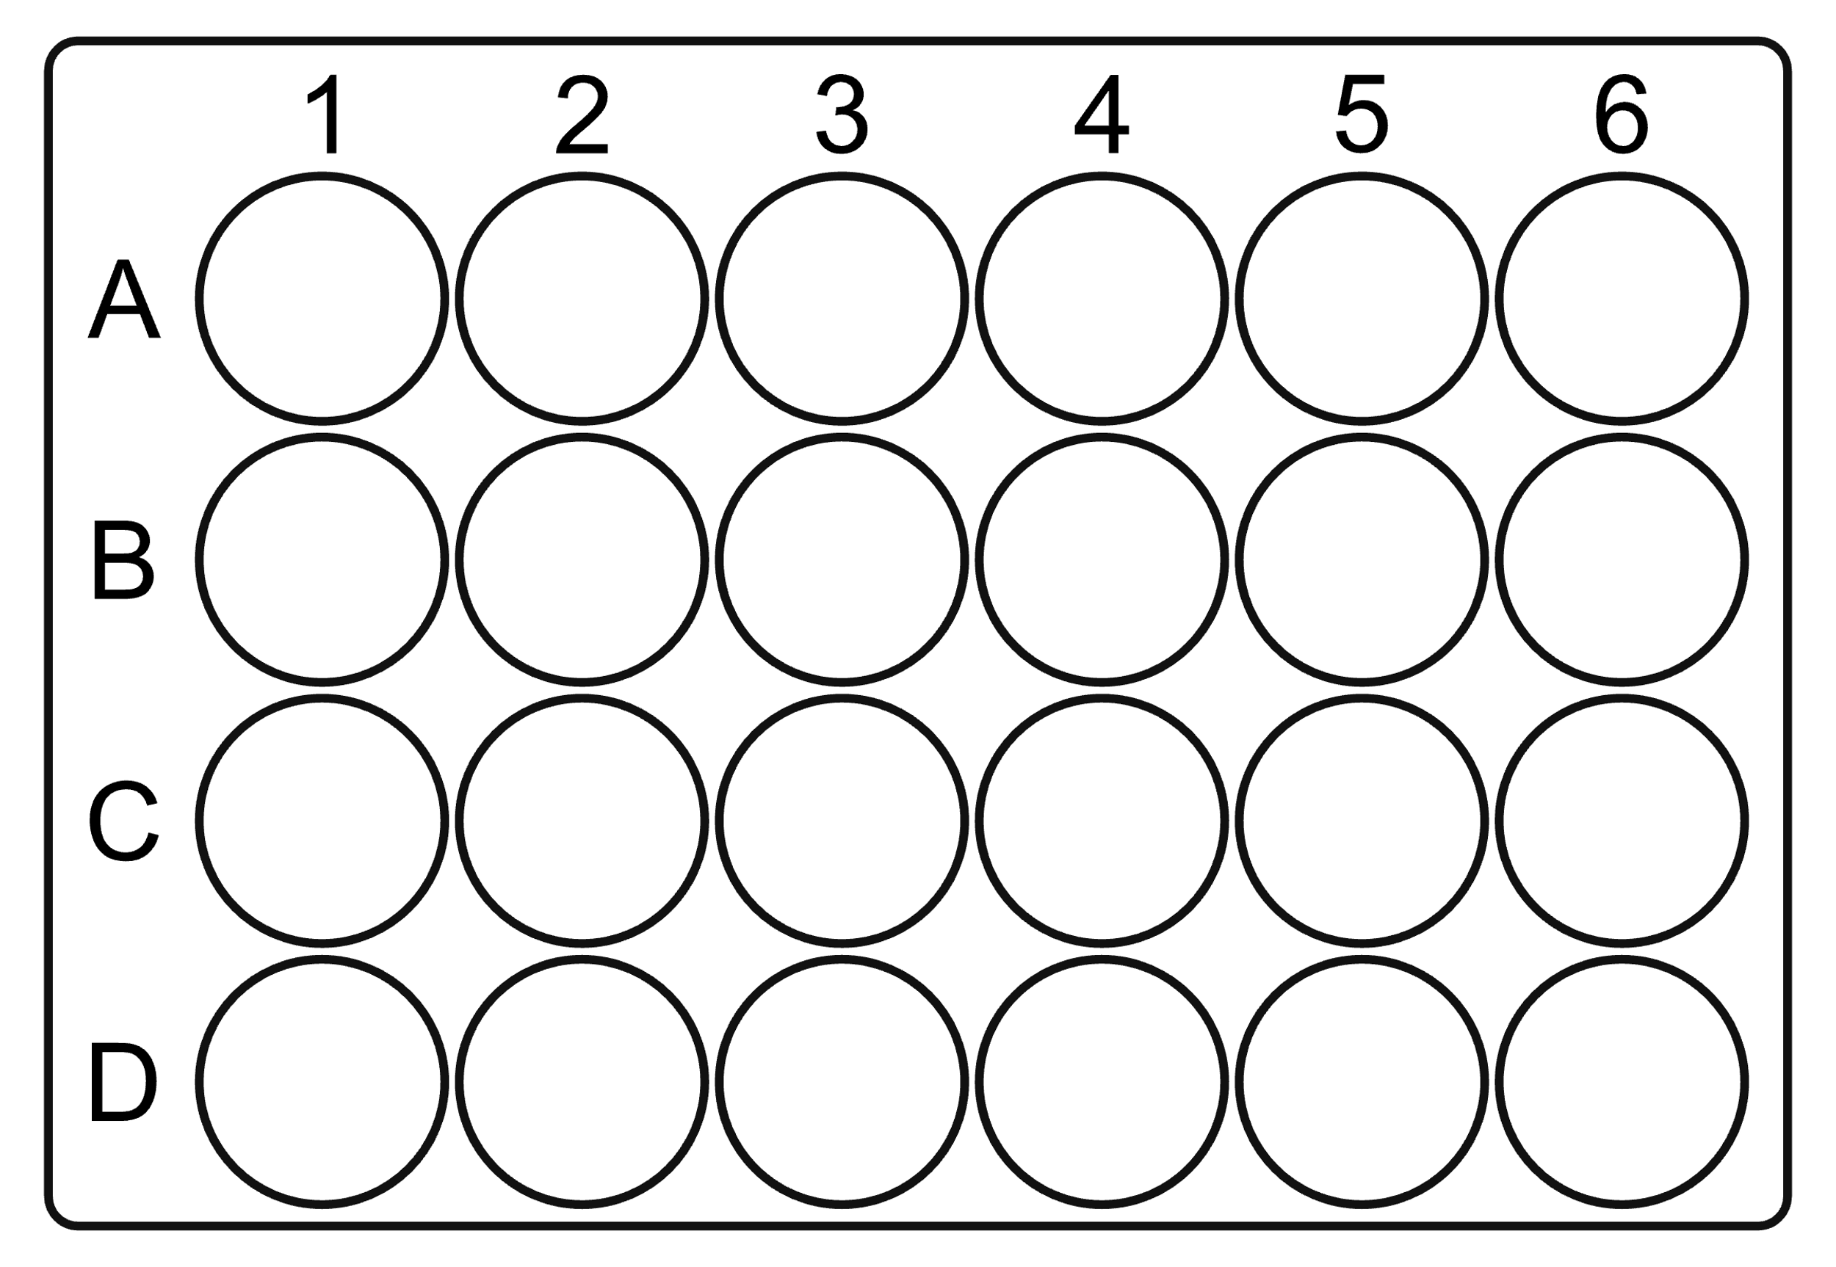
Originaldensity
Originaldensity

75%
75%
50%
50%
35%
35%
25%
25%
10%
10%
Zoo-COMBO
Zoo-COMBO
Part V – Dry filters overnight
Place 24-well plate with filters inside in an oven at 50 °C overnight to dry.

Lightly lift the filter by sliding one forceps arm underneath it. With the help of the other pair of forceps hold in place by lightly pressing on one point of the filter. Lift and push the filter with the pair that was underneath it, to fold in half. Fold in half again with the same technique. Now the filter is folded into a quarter of a circle.

